README Module 4
CS-340
Kaitlyn OConnell
2026-06-06

About the Project/Project Title
The project is a python-based MongoDB CRUD module. The purpose was to connect MongoDB, authenticate the user, and allow interaction and testing from the stored records.
The focus was implementing the C & R steps of CRUD. These steps are arguably the core foundation of database driven applications. The module should allow the new records to be inserted into the DB and existing records to be retrieved using a simple query.

Motivation
The purpose of the project was to gain experience working with databases in Python. Building Create & Read functionality, learning how applications interact with MongoDB, and understanding how data is retrieved and stored in systems.

Getting Started
Starting off, the environment needed to be set up so the records could be imported. A DB named aac was created in the past. Then the dataset aac_shelter_outcomes was imported into the DB. A user was created for authentication and access to the sensitive data. The system then required access to aacuser via a personally selected password.
After the setup, the create function inserts a new document into MongoDB. The read function retrieves the documents via the query. The functions are both handled via the python class AnimalShelter.

Installation
Python – language used to writ and run the CRUD module.
MongoDB – DB used to store animal records
Pymongo – library to connect python to MongoDB
Bson.objectid – used to handle mongodb documents

Usage
The module is used to insert and retrieve records from the DB.

Code Example
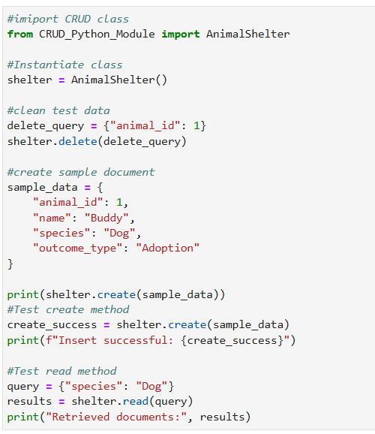
Tests
Simple insert and read operations were utilized for the tests.

Screenshots
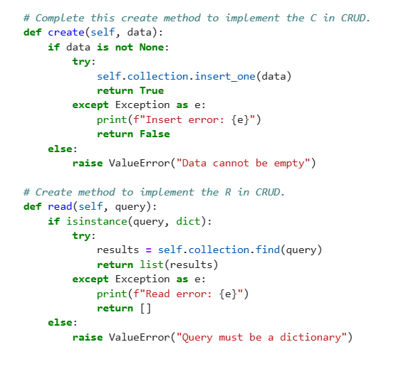
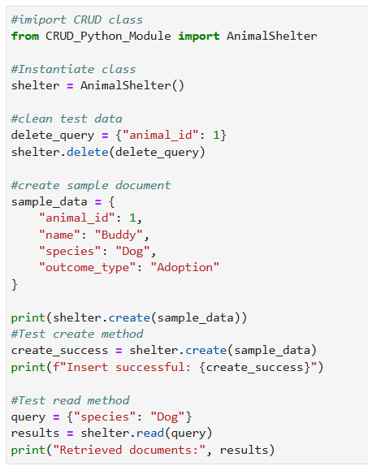

Roadmap/Features (Optional)
Eventually, the U & D (update & delete) functionality will need to be completed. Added input validation would be helpful as well.

Contact
Your name: Kaitlyn OConnell

